Take Me  Home
Predicting Adoption Wait Times in Animal Shelters Using Machine Learning
Hsien-Hsin Sean Lee · Lindsay Yu
MIT Sloan School of Management · 15.727 Analytical Edge · Spring 2026

Project web pilot site: https://hsienhsinlee.github.io/dogs/
Project GitHub repo: https://github.com/hsienhsinlee/MIT_15.727.AE_TakeMeHome

1. Introduction & Background
Animal shelters across the United States take in millions of animals each year while operating under severe resource and budget constraints. Allocation decisions—which animals receive behavioral rehabilitation, premium placement, medical intervention, or targeted marketing—are typically made by staff based on experience and intuition rather than systematic data analysis. These decisions occur at scale and under time pressure, and they directly shape adoption outcomes. For animals at risk of long shelter stays, early proactive intervention can be life-saving; without it, prolonged shelter stress degrades behavior and further reduces adoptability.
We present “Take Me Home,” a machine learning platform based on the XGBoost algorithm that predicts a given animal’s expected length of stay (LOS) at the moment of shelter intake—before any behavioral assessment or adopter interaction has occurred. By surfacing individualized, data-driven risk scores at intake, the tool enables shelter operators to immediately identify high-risk animals, prioritize limited resources toward cases most in need, and ultimately reduce chronic shelter crowding and euthanasia rates. We deploy the “dog model” as an interactive web application (hsienhsinlee.github.io/dogs/) designed for non-technical shelter staff. Separately, we also built a similar model in parallel to predict a cat’s LOS to demonstrate cross-species applicability of our methodology.

2. Methods

2.1 Training Data Collection
We use the Austin Animal Center (AAC) Shelter Outcomes dataset, a publicly available record of all intakes and outcomes at Austin, Texas’s municipal open-admission shelter. First of all, data entries provided by ACC were not well organized. The “intake” data and the “outcome” data of animals were kept in two separate CSV files of slightly distinct formats. We implemented a Python script to clean up and combine these two files into one “combined_austin_shelter_data_v1.xlsx” as input for our model training. Our filtering to animal records with confirmed adoption outcomes and capping LOS at 365 days to remove extreme outliers, the working dataset contains a total of 172,227 records spanning from 2013 to 2025. Each record includes intake type, species, breed, coat color, age at intake, sex, intake conditions, intake date, and outcome date.

2.2 Feature Engineering
The target variable is log-transformed (log₁+p of LOS in days) to address the strong right skew in shelter stay distributions. We engineer 16 features as shown in Figure 1 across four major categories: (1) Animal characteristics—age in days, age bucket (puppy/young/adult/senior), sex, neuter status, mixed-breed flag, and primary coat color; (2) Breed—target-encoded breed groupings plus two domain-specific binary flags: is_large_breed (Labrador Retrievers, German Shepherds, Rottweilers, and similar breeds) and is_bully_breed (Pit Bulls, Staffordshire Terriers, American Bulldogs, and related breeds with potential adoption bias); (3) Intake context—intake types (stray, owner surrender, public assist, etc.) and medical conditions (normal, medical, injured, pregnant); (4) Temporal—intake month and day of week to capture seasonality. A sick_senior interaction flag marks dogs that are both medically compromised and over six years old—historically the hardest population to place. All six categorical variables are encoded with 5-fold target encoding to prevent target leakage.

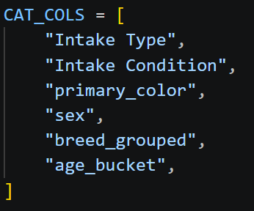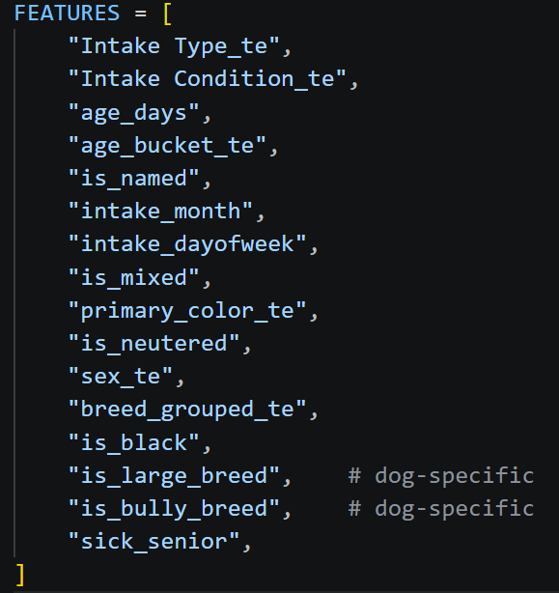
Figure 1. Training Data Set: Categories and Features

2.3 Predictive Model
We trained XGBoost (eXtreme Gradient Boosting) models with hyperparameters optimized for generalization: 600 estimators, maximum depth 6, learning rate 0.04, and 80% row and column subsampling (Figure 2). We first trained a “unified” model using data from all animals. In response to TA Dewang Agarwal’s feedback on our project proposal, we also trained species-specific models including a “dog-only” model and a “cat-only” model by filtering the dataset by animal type and compared performance across all three models.
The models predict log-transformed length of stay (LOS), with output predictions reported in “days”. The dataset was split into 80/20 train and test sets. Performance is evaluated using log-scale R² (the proportion of variance explained in log space) and Mean Absolute Error (MAE) in days. Model interpretability is provided via SHAP (Shapley additive explanations), which decomposes each prediction to quantify the contribution of individual features. All models were trained on our local notebook CPU (11th Gen Intel Core i7-1185G7 @3GHz).

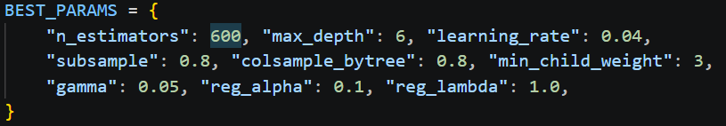
Figure 2. XGBoost Hyperparameters for Model Training

2.4 Clustering & Survival Analysis
K-Means clustering (k = 5, selected via the elbow method) is applied on the full scaled feature matrix to segment incoming dogs into five distinct adoption risk profiles (Error! Reference source not found.). Kaplan-Meier (KM) survival curves visualize adoption rate differences across two subgroups: Non-bully and Bully breeds. A Cox Proportional Hazard (CPH) model then estimates per-feature hazard ratios adjusted for all other covariates, providing a statistically grounded view of which factors most influence adoption speed. More analysis is discussed in Section 3.

3. Results

3.1 Model Performance
The XGBoost-based dog model achieves a log-scale R² value of 0.361 with an MAE of 19.4 days on the held-out test set (Table 1), indicating reasonably strong performance given the inherent noise in human adoption decisions. As a reference point, a log-scale R² > 0.30 is often considered indicative of a useful predictive model for classification.
The cat model, on the other hand, achieves an even higher log R² of 0.421, suggesting cat adoption outcomes are somewhat more predictable from observable intake attributes.
In contrast, the “unified” model, trained by pooling all species together, performs the worst, with a log-scale R² of 0.337, highlighting the value of species-specific modeling suggested by Dewang.
The predicted vs. actual scatter plot for the dog-only model (Figure 3) shows strong calibration for short-stay dogs (0~75 days, where most adoptions occur), with systematic underprediction for very long stays. This pattern is expected due to the log-transformation of the target variable and the absence of behavioral information in intake records.

Algorithm | Species | Log R² | MAE (days)
XGBoost | Dog | 0.361 | 19.4
XGBoost | Cat | 0.421 | 19.6
XGBoost | Unified | 0.337 | 22.3
Table 1. Predictive Model Performance Summary

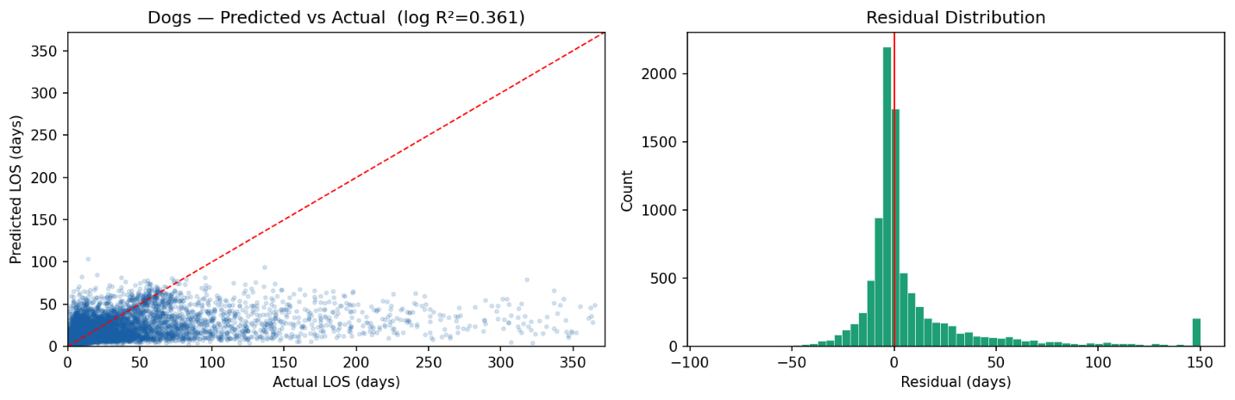

Figure 3. Dogs — Predicted vs. Actual LOS (left) and Residual Distribution (right). Log R² = 0.361, MAE≈19 days.

3.2 Feature Importance (SHAP)
SHAP analysis in Figure 4 clearly shows the relative importance of each feature of an intake dog. Age (age_days) is the dominant predictor by a wide margin—older dogs have substantially longer stays, with high age values driving large positive SHAP contributions (longer predicted LOS). Breed ranks second, capturing the substantial heterogeneity in adoption rates across breed types. Strikingly, having a name (is_named) at intake ranks third: named dogs are consistently adopted faster than unnamed animals, with is_named = 1 pushing predictions toward shorter stays. Neuter (is_neutered) status and age bucket reinforce the age signal. Intake condition ranks sixth (medical and behavioral conditions lengthening stays), while “bully” breed status contributes independently at rank eight.
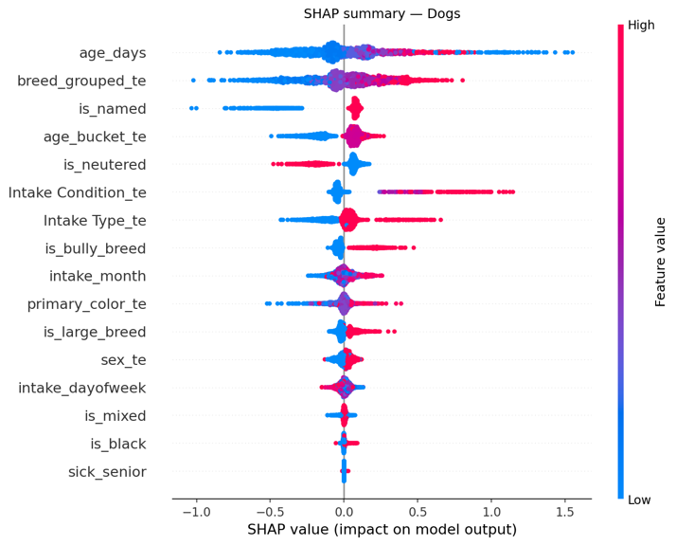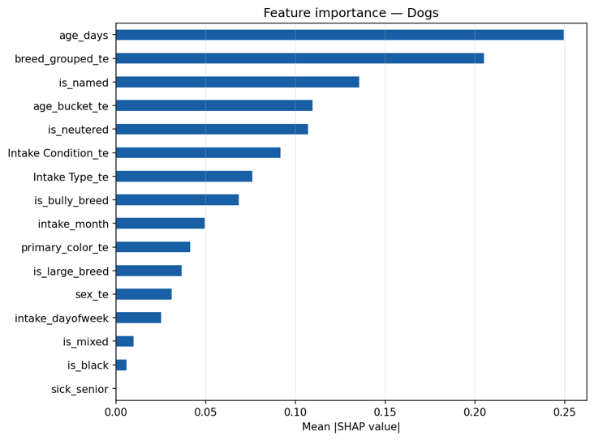
Figure 4 SHAP Feature Importance — Beeswarm plot (left) and mean SHAP value bar chart (right).

3.3 Survival Analysis
Kaplan-Meier curves (Figure 5) reveal a stark and persistent disparity between bully and non-bully breeds. By day 30, approximately 75% of bully breed dogs remain unadopted versus roughly 40% of non-bully dogs—a gap that persists throughout the 180-day observation window, with bully breeds retaining a substantially higher probability of still being in the shelter at every time point. The Cox Proportional Hazard model (Figure 6) confirms the “bully” breed effect with statistical significance, similar to dogs conditioned with “nursing” and shows that normal intake condition, relative to medical and behavioral conditions, independently accelerates the adoption hazard (i.e., shortens expected LOS).
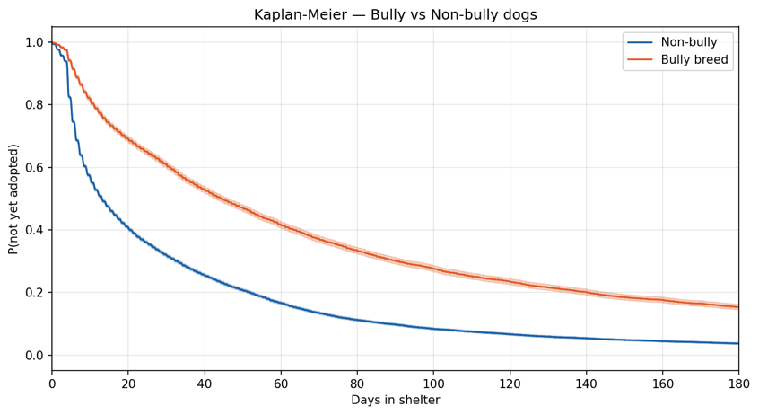
Figure 5. Kaplan-Meier Survival Curves — P(not yet adopted) for Bully vs. Non-Bully breed dogs over 180 days.

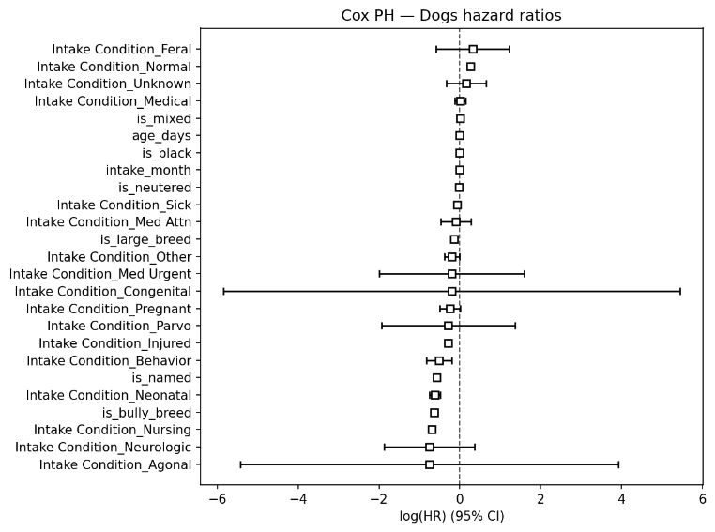
Figure 6. Cox Proportional Hazards Analysis for different parameters

3.4 Adoption Risk Profiles
K-Means segmentation identifies five interpretable adoption profiles (Table 2). Cluster 0 represents fast movers—dogs with a median LOS of approximately 7~8 days, typically young, named, neutered animals of popular breeds—who require minimal additional intervention. Clusters 1 and 2 correspond to moderate-risk cohorts, with median LOS in the 12~20 day range. Clusters 3 and 4 are high-risk groups, with median LOS exceeding 30 days and high variance; these dogs tend to be older, of stigmatized breeds, unnamed, or arriving with medical conditions. Intervention resources should be prioritized toward Clusters 3 and 4 from their day one in the shelter.
Cluster | Profile | Expected LOS
0 | Young, named, neutered, non-bully, good condition | Shortest — quick adoption
1 | Mixed profile, named, moderate age | Below average
2 | Older or unneutered, or stray intake | Average
3 | Large/bully breed, or sick/senior | Above average
4 | Bully breed + sick/senior + unneutered, poor condition | Longest stay
Table 2. LOS-based K-means Clustering for dogs

4. Discussion and Conclusion

4.1 Key Insights
Three findings carry direct operational significance for shelter management. First, age and breed are the dominant drovers of adoption speed, and both are observable at intake without requiring any behavioral assessment. This enables shelters to identify high-risk dogs or animals within minutes of arrival and act immediately, rather than reacting after weeks of unsuccessful adoption attempts. Second, the naming effect (ranked third in SHAP importance) suggests that assigning memorable names to unnamed animals at intake may measurably reduce LOS at near-zero cost. This represents a simple, immediately actionable policy lever that requires no additional technology or budget. Third, the disparity associated with bully-type breeds is substantial: without proactive intervention beginning on day one, these animals tend to experience significantly longer shelter stays, regardless of their individual temperament or health condition.

4.2 Limitations
The model is trained exclusively on data from Austin Animal Center (AAC) Shelter. Although the data were collected across a span of 12 years, its generalizability to shelters in different geographic, demographic, or policy contexts is untested. A log-scale R² of 0.361 (from our dog-only model) reflects substantial unexplained variance, largely attributable to factors not captured at intake, such as an animal’s temperament, energy level, leash manners, and interactions with children or other animals. All of which are critical to adoption decisions but absent from the intake records we used for model training.
The model also systematically underpredicts very long stays (>100 days), which represent the most operationally challenging cases. Finally, the observed naming correlation may reflect reverse causation: experienced staff may instinctively name animals they sense are likely to be adopted quickly, rather than naming itself driving adoption success.

4.3 Future Directions & Implications
Future work could incorporate image-based features, such as photo quality, animal expression, lighting, and framing, which have been shown to influence online adoption interest. Expanding the model to multi-shelter datasets across different cities and shelter policies would enable a more rigorous assessment of geographic generalizability. In addition, a dynamically updating model that revises LOS predictions as animals accrue time in shelter could substantially improve accuracy for the long-stay cases that are most challenging to resolve.
Even at moderate predictive accuracy, “Take Me Home” enables a structured form of risk-based triage that is currently absent from most shelter workflows. By flagging the top quintile of predicted long-stay animals for proactive intervention on intake day, rather than weeks into their stay, shelters may effectively improve outcomes. The model’s interpretability via SHAP attribution and cluster-based segmentation further ensures that predictions are actionable for non-technical staff, helping bridge the gap between machine learning outputs and real-world shelter operational decisions where every day matters.
Live pilot web: hsienhsinlee.github.io/dogs/

